**GITHUB Techniques and Uses**

Introduction

Git is a version control system using web based services. Git is a command line tool which has to be downloaded to be used in sync with the Github. Developers can store their projects in GITHUB.COM and network/share with likeminded people. Git and Github.com can be used in sync to develop and share and also for version control of the projects.

Github.training.com githubtraining

How To Install and setup Github in desktop

1. Go to <https://desktop.github.com/> and download github for desktop and install it in your machine.
2. Set username and Email id in Git. Use the following command to set up for the machine.

$ Git config –global user.name “saiksbp07”

$ Git config –global user.email [saikatgupta20@gmail.com](mailto:saikatgupta20@gmail.com)

1. Go to the Github.com and sign up by providing user name, email id which are same as is set in the Git Bash

How to Create a Repository in LOCAL machine and Update it in Remote Server

1. Know the current working directory using list command

$ ls –l or ls

1. Using cd command go the folder where a new repository is to be created

$ cd <directory Name>

1. Now make a git repository by mkdir

$ mkdir <reponame>.git

1. Now create a repo in gitHub website

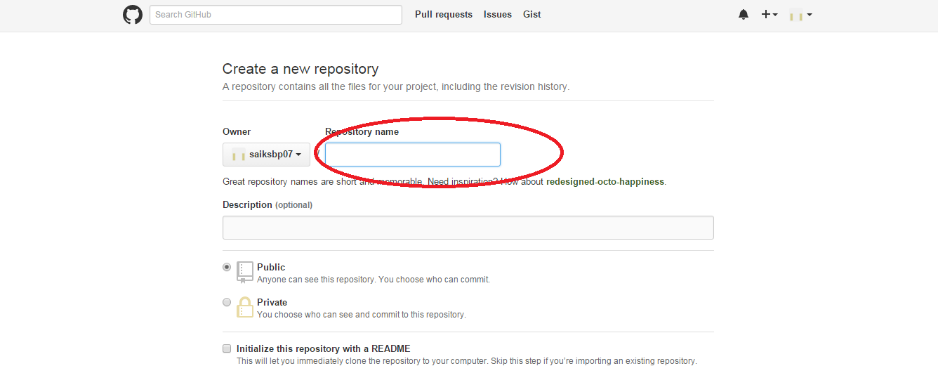

1. Put repository name in the place given and CREATE REPOSITORY in the github account.
2. Now in the git bash command prompt change directory to the repository folder in the local machine.
3. Put the work for which version control is required in the <repositoryname>.git folder in the local machine.
4. Execute the following command to save the work in the Github web Repository.

$ git init #-----to initialize the repository

$ git add <filename> #----add file for version control

$ git commit –m #----commit the changes made to the repository with a version

#----control message capturing the changes

$ git remote add origin <url> #----add the url of the repository which was created to

#---to save the local work repository

$ git push origin master #----push the local repository to the github web

#---- repository. Validate with userid and password

The work will be stored in the web repository

$ git push –u origin master #--- to update an existing repository to the web repo